# User Documentation

## System Overview

In this system there are just two users that can login to this system the first on is the ophthalmologist admin and the second user is the patient admin each user has username and password so he can login, the ophthalmologist username: Opthalmologist_admin and the password: 0000 moving on to the patient username: Patient_admin and his password: 0000.

Each user has three pages to interact with them in this system. Starting with the ophthalmologist admin user as I said he will see three pages after logging in, the first one is the ophthalmologist view page which will allow you as an ophthalmologist admin user just to see and view all the ophthalmologists data and information, the second page which is insurance companies view page which will allow you as an ophthalmologist admin user just to see and view all the insurance companies details and information, and the last page is the ophthalmologist page which will allow you as an ophthalmologist admin user to view and delete and insert and also edit or update any ophthalmologist information.

Moving on to the patient admin user as I said he will see three pages after logging in, the first one is the patient view page which will allow you as an patient admin user just to see and view all the patient data and information, the second page which is insurance companies view page which will allow you as an patient admin user just to see and view all the insurance companies details and information, and the last page is the patient page which will allow you as an patient admin user to view and delete and insert and also edit or update any patient information

## Using the system

**Note**: describe the system by its pages and functionalities per users. You need to add screenshots.

**For Opthalmologist_admin user**:

1. Open [www.localhost/Final_project.com](http://www.localhost/Final_project.com)
2. Login with your username as: Ophthalmologist_admin and your password as: 0000.
3. You will find all the pages names in a bar above the screen:



1. If you press on the first page which is the insurance companies view you will be able to see all the details of the companies, but you cannot do any operating on this page you can just view



1. If you press on the second page which is the ophthalmologist, you will be able to see all the information of the ophthalmologists and also you can edit delete insert.



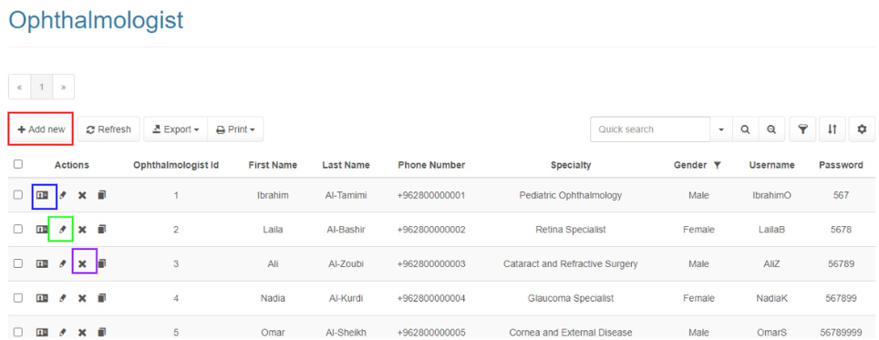To insert press the red button:

To view press the blue button:

To edit press the green button:

To delete press the purple button:

1. If you press on the last page which is the ophthalmologist view you will be able just to view all the ophthalmologist information, but you cannot do any operation.



**For Patient_admin user**:

1. Open [www.localhost/Final_project.com](http://www.localhost/Final_project.com)
2. Login with your username as: Patient_admin and your password as: 0000.
3. You will find all the pages names in a bar above the screen:

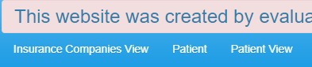

1. If you press on the first page which is the insurance companies view you will be able to see all the details of the companies, but you cannot do any operating on this page you can just view

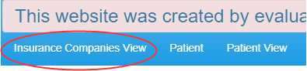

1. If you press on the second page which is the patient you will be able to see all the information of the patient and also you can edit delete insert.

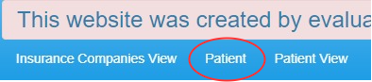

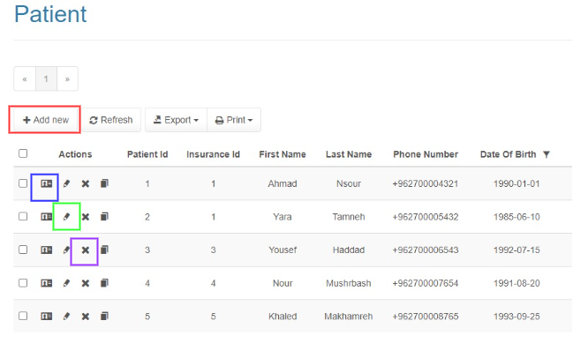To insert press the red button:

To view press the blue button:

To edit press the green button:

To delete press the purple button:

1. If you press on the last page which is the patient view you will be able just to view all the patient information, but you cannot do any operation.

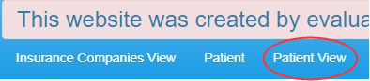

## Frequently asked questions

**For Opthalmologist_admin user**:

**How do I login to the system?**

Open the provided website then use the username ‘Ophthalmologist_admin’ and the password ‘0000’ to log in.

**How can I update the ophthalmologist’s information?**

go to the ophthalmologist page,



and then you will find some icons on the left, chose the one that have the pencil shape



**How can I add new ophthalmologist?**

Go the ophthalmologist page

and then you will find an icon in the head of the page called add new

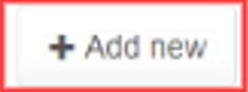

**can I view patient details?**

You as an ophthalmologist admin user, you can just view the ophthalmologist’s information and also view the insurance companies details

**What if I forget my password?**

Use one of the phone number or the email that are mentioned in the end of this paper and then ask for the admin saif haddad and he will send you the password

**For the patient_admin user:**

**How do I login to the system?**

Open the provided website then use the username ‘Patient_admin’ and the password ‘0000’ to log in.

**How can I update the ophthalmologist’s information?**

Go to the patient page

and then you will find some icons on the left, chose the one that have the pencil shape



**How can I add a patient to the system?**

go to the patient page

and then you will find an icon in the head of the page called add new



**What if I forget my password?**

Use one of the phone number or the email that are mentioned in the end of this paper and then ask for the admin saif haddad and he will send you the password

**Can I add multiple contact numbers for a single patient?**

Our current system just allows to put just on number, in case there was an update we will let you know

**Is my login information secured?**

yes it is secured, fell safe will using

## Contact information

Phone number: 0797155936

Email: Haddadlove2003@gmail.com